Course Title: Late 20th Century
Grade level: 4th
Unit: Late 20th Century
Amanda Heminger

Abstract
This unit introduces some of the more modern events that have had an effect on Indiana State Parks. The students start with investigating some national events that had a direct/indirect effect on the parks in this state. The students will use various methods to study some of the major events that took place in the later 1900s, and come up with ways those events effected parks in the area. After carefully considering the effects of the major events, the students will consider their own effect on their environment by calculating their carbon footprint on “The Kid’s Carbon Calculator.”

Focus Questions
- How have major events in our recent history effected our parks either directly or indirectly?
- How do our own actions effect our parks, and how can we help preserve their existence?

Instructional Resources:

Indiana Memory:
- (Turkey Run State Park Preservation) https://digital.library.in.gov/Record/WV3_isulib-2605
- (Brown County Exhibit Promotes Forest and Wildlife Preservation) https://digital.library.in.gov/Record/IHS_dc034-345

Baby Boom
“The 1950s.” History. http://www.history.com/topics/1950s.

Increase Visitation
“Recession drives down national park visitation, study finds.” (October 19th, 2012). PhysOrg. http://phys.org/news/2012-10-recession-national.html.

Earth Day
“Earth Day: The History of a Movement.” http://www.earthday.org/earth-day-history-movement.

http://www.youtube.com/watch?v=QpC10pQv0O8

The Environmental Movement
“The Modern Environmental Movement.” American Experience Timeline. http://www.pbs.org/wgbh/americanexperience/features/timeline/earthdays/

Indiana Nature Preserves Act - 1967
Bacone, J., Dunbar, R., Eddy, B., Hedge, R., Homoya, M., Swinford, T. “Keeping what we’ve ‘got’.” Indiana Department of Natural Resources. http://www.in.gov/dnr/naturepreserve/5562.htm

Indiana Heritage Trust
Indiana Hertiage Trust – Home page - http://www.in.gov/dnr/heritage/

National Resources Foundation
Indiana Natural Resources Foundation Home page - http://www.in.gov/inrf/what_we_do.html

Carbon Calculator
http://www.cooltheworld.com/kidscarboncalculator.php

Benchmarks | Assessment Tasks | Key Concepts
Students will:  - Identify and describe important events that changed life in Indiana between the 1940s – 1960s. (SS 4.1.13)  - Research Indiana’s modern growth due to Earth Day or other environmental movements by reading an article and watching a video.. (SS 4.1.14)  - Students will research the Indiana Nature Preserves Act – 1967 by reading the information on The Indiana Department of Natural Resources. (SS 4.1.14)  - Students will research the Indiana Heritage Trust/Natural Resources Foundation by reading two separate articles. (SS 4.1.14) | Students will:  - Make connections with the baby boom to increased visitation to Indiana parks using graphic organizers. (SS 4.1.13)  - Design five articles based on the importance of Earth Day for their school and nearest state park. (SS 4.1.14) | - Preservation  - Pollution  - Environment  - Resources

Catalogue of Lessons:

Lesson 1: The “boom” of a population

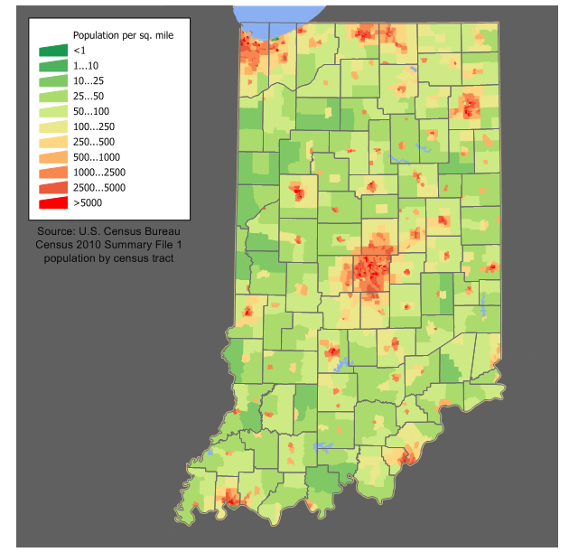
The students will read about the baby boom during post WWII (. http://www.history.com/topics/1950s), and then another article about the effect of a recession on park visitation (. http://phys.org/news/2012-10-recession-national.html). This will help students think critically about how the opposite of a recession would effect visitation, as well as some adverse effects a population growth would have on wild life, and vegetation. The students will collect this information in the form of a table. One side will represent the adverse effects of a population boom on state parks, and the other will represent the positive effects a population boom could have on state parks. The students will discuss in small groups first, making sure to back up their arguments with factual points. The class will then come together and talk about the points they came up with in small groups.

Lesson 2: The Indiana Nature Preserve Act of 1967
The teacher will discuss with the students, the Indiana Nature Preserve Act of 1967, and how it ties in with the discussion from the day before. The students will be given two maps (both below this section) where they will talk about heavily populated areas versus the location of state parks. The students will then be given a blank map where they will place two additional parks in Indiana, and explain why they decided to place the parks in those locations based on the population map. The students will make the connection to the preservation act by showing that large population growths in an area could adversely affect that park, if the preservation act was not in place.
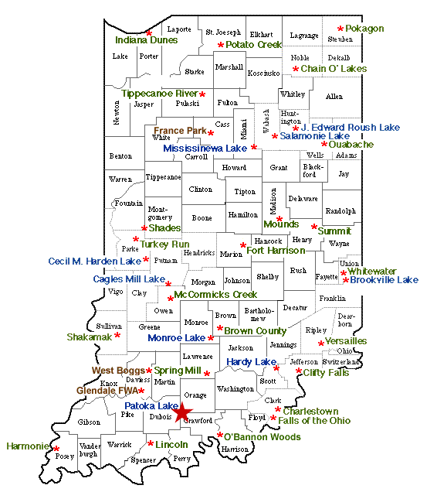

Lesson 3: Organization Support
The students will be split in half where one group will read about and research the Indiana Heritage Trust (http://www.in.gov/dnr/heritage/4426.htm), while the other half of the class will research the Natural Resources Foundation (http://www.in.gov/dnr/naturepreserve/5562.htm). The students will have a list of points to focus on, to ensure they are researching for information related to Indiana Heritage Trust and the Natural Resources Foundation. After completing their research, the class will come together to explain their findings. They will then come up with a park to fund for preservation. After talking about preservation based on population, they should have a strong understanding of why preservation is necessary. The students will be divided up to play parts of the park preservation process. Some students will represent the park, where they will argue their point on why their park needs preserved, while the other half will play the part of people representing an organization. By the end of this activity, the students representing the organizations will make a decision based on the points presented by the park representatives.

Lesson 4: Carbon Footprint
The students have discussed thoroughly about parks, the population effect, and how certain movements have worked to preserve them. The students will get to hear a urban planning representative talk about carbon footprints and how they can best help their local parks and wildlife by decreasing their carbon footprint. The students will then take an assessment online that helps them find out what their own footprint is (http://www.cooltheworld.com/kidscarboncalculator.php). This will help the students understand some of the problems that were caused by the baby boom of the earlier years, as well as the pollution that was taking place with out consequences. Each student will then have to create a promise to Earth to reduce their carbon footprint in three different ways.

Lesson 5: School Newspaper for Earth Day
The students will read an article (http://www.earthday.org/earth-day-history-movement) and discuss the benefits that come from having an Earth Day in Indiana. They will also watch a video (http://www.youtube.com/watch?v=QpC10pQv0O8) that describes activities that take place in Indianapolis on Earth Day to both ways to help the Earth, and ways to celebrate the anniversary of Earth Day. They will discuss various topics that they find to be the most important regarding this national holiday. The students will then be divided into five groups where they will write their article that must include a problem, possible solutions, and possible effects if the problems are not fixed. The students will graded for their group’s final article. It must contain the parts discussed previously. The teacher will act as editor for the final product. Also, the students will be given an opportunity to hand out their News Paper to local residents at the nearest State Park.

Assessment Tasks

Course Title: Baby Boom!

Abstract

This task will have students looking at the historical event such as the baby boom and how it affects visitation to state parks. The teacher will prompt the students to start thinking about how the population rise might have affected the parks.

Prompt

Students will be given two different articles. One article is based on the actual outline of the cause of the baby boom, and how it affected culture at the time it happened. The students will then read an article regarding how a recession and population slow down effected park visitation. This will indirectly get students thinking about what would happen if the opposite thing happened. The students will be asked to think about the effects on wildlife, monetary intake, and possible space issues.

Directions

“We will be discussing how the baby boom has affected our culture, but more specifically how it affected our state parks during that time period. We’ve looked at two articles that should help us better decide on some ways that the parks were affected. You will be broken up into groups of three or four, and you will begin filling out a table, which is divided up into positive and negative effects the baby boom would have had on our state
parks. Please make sure that you have at least three on each side before we come together as a group. This task will start setting us up for the Earth Day paper we will be writing for later in this unit.”

Procedures

- Teacher will hand students two articles. Both of which the students will come together for a class discussion before continuing on with the next one.
- The students and the teacher will focus on effects of a baby boom on state parks, including any local parks that the students can think of.
- Students will split up into groups of 4 to start filling out a table that talks about positive and adverse effects the population growth might have on the parks.
- The students will present these to the rest of the class where the teacher will type up the list they come up with.
- Students will then orally present their findings to a park representative.

Positive effects | Negative effects

Scoring Rubric

Benchmark | 1 | 2 | 3 | 4
- Identify and describe important events that changed life in Indiana between the 1940s – 1960s. (SS 4.1.13) | Students were missing 3 or more effects of the baby boom on state and local parks. | Students were missing 2 effects of the baby boom on state and local parks. | Students were missing 1 effects of the baby boom on state and local parks | Students included all 6 points of the positive and negative effects the baby boom had on state and local parks.

Course Title: Save what we have!

Abstract:

This task gives the students the chance to write about what they’ve learned in the form of a newspaper. They have spent the entire unit talking about movements that have been made, and organizations that been created to make sure the parks are around for further generations to enjoy. The task at hand is to create a newspaper with about five articles, all focusing on some aspect of what the unit has discussed. The students will run their idea by the teacher before they begin writing their article.

Prompt:

Various organizations have been created to help preserve our state parks, which include The Indiana Nature Preserve Act of 1967, the Indiana Heritage Trust, and the Natural Resources Foundation. The students will have carefully researched all of these subjects, by reading articles, talking to a park representative, and watching a video on Earth Day. The goal is to come up with a newspaper that focuses on these things learned as well as come up with solutions to how we could continue the push to preserve our state parks.

Directions:

“We have carefully considered all of the major events and movements that have come together as a result of a baby boom in the late 20th century. We know that there have been effects on our parks, and we also know that certain organizations and movements have helped preserve these parks. We have discussed our carbon footprints to better help us understand how much one person can affect the earth around us. You have also chosen your article focus for our Earth Day newspaper. You will need to focus in on three things. First you will talk about what the problem is related to your topic, some possible solutions, and some possible effects if this problem is not fixed. I will be the one to do the final editing, but I fully expect you to look over your work for grammar errors, and spelling errors. Remember that we will be handing out this newspaper at our local library.

Procedures:

- Teacher will recap the unit’s articles, discussions, presentation by park representative, and carbon footprint readings.
- The teacher will remind students of their group members, and what topic they chose to focus on.
- The teacher will direct the students to focus on the three major points their article is supposed to make. (the problem, a possible solution, and possible effects if a change doesn’t happen)
- The students will be reminded that they will be passing this newspaper out in the community, so to use their best writing skills.

Scoring Rubric

Benchmark | 1 | 2 | 3 | 4
- Research Indiana’s modern growth due to Earth Day or other environmental movements by reading an article and watching a video. (SS 4.1.14)  - Students will research the Indiana Nature Preserves Act – 1967 by reading reading the information on The Indiana Department of Natural Resources. (SS 4.1.14)  - Students will research the Indiana Heritage Trust/Natural Resources | Student did not include the major parts of the article;  problem, possible solution, and possible problem if a solution is not enacted. | Students addressed only one part of the article;  problem, possible solution, and possible problem if a solution is not enacted. | Students addressed only two parts of the article; problem, possible solution, and possible problem if a solution is not enacted. | Student addressed all parts of the article; problem, possible solution, and possible problem if a solution is not enacted.

